**Fault Tolerance in Microservices [Hystrix (Circuit Breaker)]**

Example:

Earlier we were fetching the list of citizens along with vaccination center id's based on

the vaccination center id using postman with this URL: http://localhost:8082/vaccinationcenter/id/101  
and we were able to get the list of citizens who are registered the vaccination center having id: 101 given below

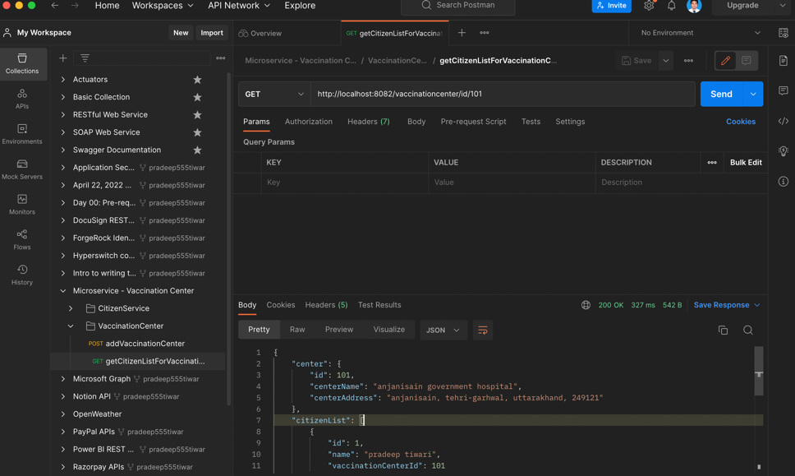

Question: Now the question arises that what is fault?

Answer: So, the fault can arise when your citizen service is down and there could be many reason that it's down.  
In our local if we want to make down our microservice citizen-service down then just close the server of citizen service in cloud.  
  
So, lets implement the fault. Let's do make things below where   
 1. Eureka Server service is ON  
 2. Vaccination service is ON  
 3. Citizen service is OFF  
So, we have turn on the first 2 service and we turn off the citizen service to implement fault.  
As soon as we close / turn off the citizen service there is a fault.

Now as we have turn off the citizen service there is fault (Internal Server Error – Status 500) when we are hitting the vaccination center service with id 101 as show below.

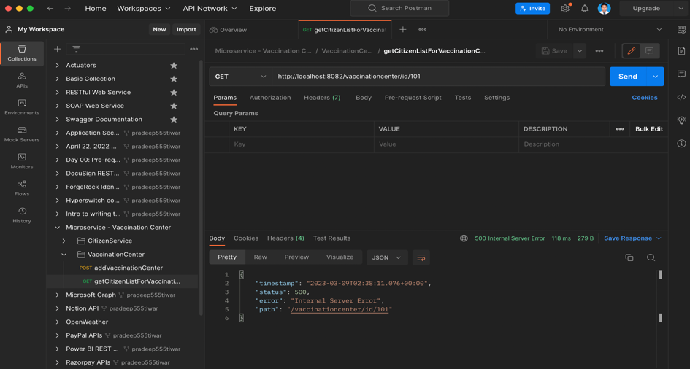

So, now we will get to know what is fault tolerance.

Question: What is Fault Tolerance?  
Answer: Fault Tolerance is the property that enable a system to continue operating properly in the event of the failure of some of its components.

So, if what we have to do to make it fault tolerant?

Well, we have to configure the circuit breaker design pattern which says that whenever there is a particular microservice is down then stop calling that down service and rather call a fallback method. We will see how to configure the fallback method.

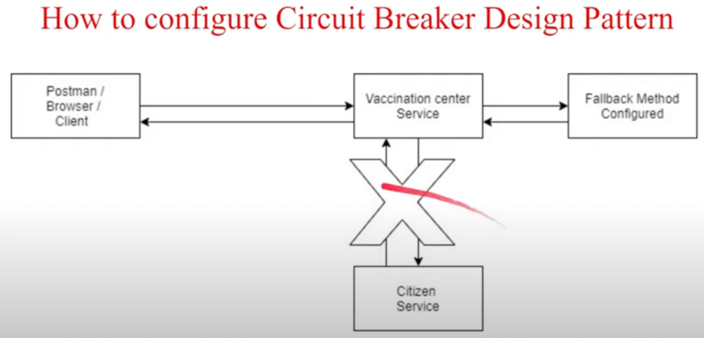

In below diagram we would see how circuit breaker design pattern works. So we have vaccination center service, configured circuit breaker and user service.

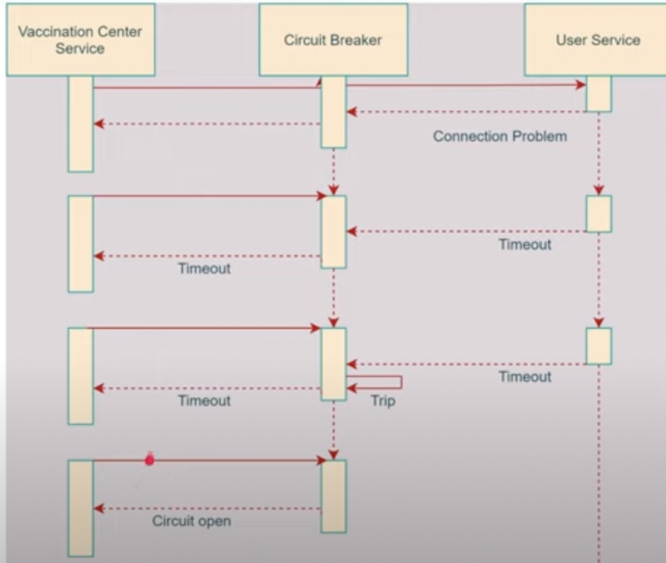

Given below in code we have method findListOfCitizenWithCenter() where we are hitting vaccination center service and internally it is hitting the user service which is nothing but a citizen service through the rest template. So, it was doing good until we didn’t stop the citizen service but as soon as we stop the citizen service it started throwing “Internal Server Error Status – 500” which is nothing but a connection problem.

